**COMMUNITY SERVICE PROJECT**

**A STUDY ON SOME ASPECTS OF WOMEN’S HEALTH IN VARIOUS**

**AREAS OF VISAKHAPATNAM CITY**

*A project submitted in partial fulfilment of the*

*Requirements for the award of*

Bachelor of Computer Applications Data Science

By

**PAMPANA JAI KIRAN**

**Regd.No: 2021-2222043**

Under the guidance of

Smt. P. Anantha Lakshmi

Assistant Professor

Department of Computer Applications (UG)

Gayatri Vidya Parishad College for Degree and P.G. Courses (A)

Affiliated to Andhra University

Visakhapatnam

2021-2024.



Smt. P. Anantha Lakshmi

Project Guide

Sri. P. Venkata Rao

Prof. I. S. Pallavi

Head of the Department

Director of MCA

External Examiner

This is to certify that the project report titled **“A STUDY ON SOME ASPECTS OF WOMEN’S HEALTH IN VARIOUS AREAS OF VISAKHAPATNAM CITY” is the bonafied record of project work carried out by PAMPANA JAI KIRAN Regd.No:2021-2222043** are the students of this college, during the academic year 2021-2024, in partial fulfilment of the requirement for the award of the Bachelor of Computer Applications in Data Science.

**CERTIFICATE**

**GAYATRI VIDYA PARISHAD COLLEGE FOR**

**DEGREE AND PG COURSES (A)**

**(Affiliated to Andhra University)**

**Rushikonda, Visakhapatnam-45**

**Bachelor of Computer Applications Data Science**



**DECLARATION**

This is to certify that the project report titled “**A STUDY ON SOME ASPECTS**

**OF WOMEN’S HEALTH IN VARIOUS AREAS OF VISAKHAPATNAM CITY”** submitted for

the Bachelor’s degree is our original work and the dissertation has not formed the basis for

the award of any degree, diploma or other similar title. Further, I state that this is an

original piece of work that has not been published or submitted for publication in any

magazine or journal.

**PAMPANA JAIKIRAN**

**Regd.no: 2021-2222043**

**ACKNOWLEDGEMENT**

I am deeply indebted to Gayatri Vidya Parishad College for Degree and P.G. Courses (A), Visakhapatnam, affiliated to Andhra University for awarding Graduation to pursue our research on “**A STUDY ON SOME ASPECTS OF WOMEN’S HEALTH IN VARIOUS AREAS OF VISAKHAPATNAM CITY”** acknowledged by the Andhra University and authorities concerned.

I am thankful to ***Prof.S.Rajani, Principal,*** Gayatri Vidya Parishad College for Degree and P.G Courses (A) for support and encouragement in the completion of the project work.

I am also thankful to ***Prof.I.S.Pallavi, Director of MCA,*** Gayatri Vidya Parishad College for Degree and P.G Courses (A), for extending support in the completion the of study.

I’m also thankful to ***Sri.P.Venkata Rao, Associate Professor & HOD of BCA,*** Gayatri Vidya Parishad College for Degree and P.G Courses (A), for suggestions and encouragement.

My sincere thanks to our project guide ***Smt.P.AnanthaLakshmi, Assistant Professor,*** Gayatri Vidya Parishad College for Degree and P.G Courses (A), for her support and valuable suggestions for the completion of the project.

I’m also thankful to the college authorities, all the teaching staff and non-teaching staff of Gayatri Vidya Parishad College for Degree and P.G. Courses (A) who have been a constant source of support and encouragement during the study tenure.

I’m thankful to all the selected sample respondents whose cooperation is needed in the collection of primary data. We especially thank one and all who have directly and indirectly contributed to the making of this project.

**Pg. No**

**1. INTRODUCTION**

1.1 Life Expectancy

2

2

2

3

3

3

4

4

1.2 Social and Cultural Factors

1.3 Biological Factors

1.4 Reproductive and Sexual Health

1.5 Menstrual Cycle

1.6 Balanced Diet for Women’s Health

1.7 Balancing Calories with Activity

1.8 Exercise Regularly

**2. PROCEDURE**

2.1 Questionnaire

6

**3. DATA COLLECTION**

3.1 Sample Data

9

**4. OBJECTIVE OF THE STUDY**

**15**

**5. EXPECTED OUTCOMES**

5.1 Learning Outcomes

16

16

16

16

17

17

5.2 Personal Outcomes

5.3 Social Outcomes

5.4 Career Development

5.5 Relationship with the Institution

5.6 Benefits of the Community Science Project to Faculty Members

**6**

**ANALYSIS OF THE DATA**

6.1 Women Employability -wise Collected Data

6.2 Health Issues-wise Collected Data

6.3 Physical Wellness wise Collected Data

19

20

21

**7**

**8**

**SUMMARY**

**22**

**24**

**CONCLUSION**

**CONTENTS**

**ABSTRACT**

Women's health differs from that of men in many unique ways Women's health is an

example of population health, where health is defined by the World Health Organization as a

state of complete physical, mental and social well-being and not merely the absence of disease

or infirmity. Many groups argue for a broader definition pertaining to the overall health of

women, better expressed as "The health of women" These differences are further exacerbated

in developing countries where women, whose health includes both their risks and experiences,

are further disadvantaged. Gender remains an important social determinant of health since

women's health is influenced not just by their biology but also by conditions such as poverty.

employment, and family responsibilities. Women have long been disadvantaged in many

respects such as social and economic power which restricts their access to the necessities of

life including health care, and the greater the level of disadvantage, such as in developing

countries, the greater the adverse impact on health. Women's reproductive and sexual health

have a distinct difference compared to men's health. Even in developed countries pregnancy

and childbirth are associated with substantial risks to women with maternal mortality

accounting for more than a quarter of a million deaths per year, with large gaps between the

developing and developed countries.

1

**1. INTRODUCTION**

**1.1 Life Expectancy**

Women's life expectancy is greater than that of men, and they have lower death rates

throughout life, regardless of race and geographic region. Historically though, women had higher rates

of mortality, primarily from maternal deaths (death in childbirth). In industrialized countries,

particularly the most advanced, the gender gap narrowed and was reversed following the Industrial

Revolution. Despite these differences, in many areas of health, women experience earlier and more

severe diseases and experience poorer outcomes.

Despite these differences, the leading causes of death in the United States are remarkably similar for

men and women, headed by heart disease, which accounts for a quarter of all deaths, followed by

cancer, lung disease and stroke.

**1.2 Social and Cultural Factors**

Women's health is positioned within a wider body of knowledge cited by, amongst others, the

World Health Organization, which places importance on gender as a social determinant of health.

While women's health is affected by their biology, it is also affected by their social conditions, such

as poverty, employment, and family responsibilities, and these aspects should not be overshadowed.

**1.3 Biological Factors**

Factors that specifically affect the health of women vs. men are most evident in those related

to reproduction, but sex differences have been identified from the molecular to the behavioural scale.

Some of these differences are subtle and difficult to explain, partly due to the fact that it is difficult to

separate the health effects of inherent biological factors from the effects of the surrounding

environment they exist in. Women's XX sex chromosomes complement the hormonal environment,

as well as sex-specific lifestyles, metabolism, immune system function, and sensitivity to

environmental factors are believed to contribute to sex differences in health at the levels of

physiology, perception, and cognition.

2

**1.4 Reproductive and Sexual Health**

Women experience many unique health issues related to reproduction and sexuality

and these are responsible for a third of all health problems experienced by women during their

reproductive years (aged 15-44), of which unsafe sex is a major risk factor, especially in

developing countries. Reproductive health includes a wide range of issues including the health

and function of structures and systems involved in reproduction, pregnancy, childbirth and

child-rearing, including antenatal and perinatal care.

**1.5 Menstrual Cycle**

Women's menstrual cycles, the approximately monthly cycle of changes in the

reproductive system, can pose significant challenges for women in their reproductive years

(the early teens to about 50 years of age). These include the physiological changes that can

affect physical and mental health, symptoms of ovulation and the regular shedding of the inner

lining of the uterus (endometrium) accompanied by vaginal bleeding (menses or

menstruation). The onset of menstruation (menarche) may be alarming to unprepared girls

and mistaken for illness. Menstruation can place undue burdens on women in terms of their

ability to participate in activities, and access to menstrual aids.

**1.6 Balanced Diet for Women's Health**

A balanced eating pattern is a cornerstone of health. Women, like men, should enjoy a

variety of healthful foods from all of the food groups, including whole grains, fruits,

***Fig-1.1: Balanced Diet***

3

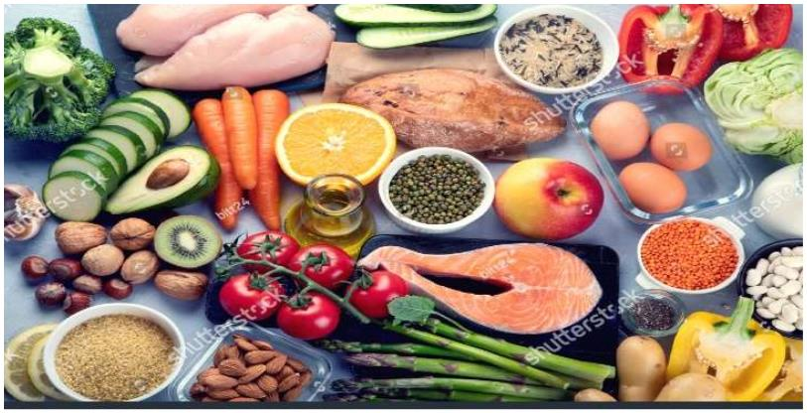

vegetables, healthy fats, low-fat or fat-free dairy and lean protein. But women also have

special nutrient needs, and, during each stage of a woman's life, these needs have to be

changed.

**1.7 Balancing Calories with Activity**

Since women typically have less muscle, and more body fat and are smaller than men,

they need fewer calories to maintain a healthy body weight and activity level. Women who

are more physically active may require more calories.

**1.8 Exercise Regularly**

Regular physical activity is vital for good physical and mental health. It helps improve

your overall health and fitness, maintain a healthy weight, reduce your risk for many chronic

diseases and promote good mental health.

Australia's Physical Activity and Sedentary Behavior Guidelines recommend that at least 30

minutes of moderate-intensity physical activity on most, preferably all, days is required for

good health. This is the same for women and men. However, only 54 per cent of Australian

women meet these guidelines.

***Fig-1.2: Exercise Regularly***

4

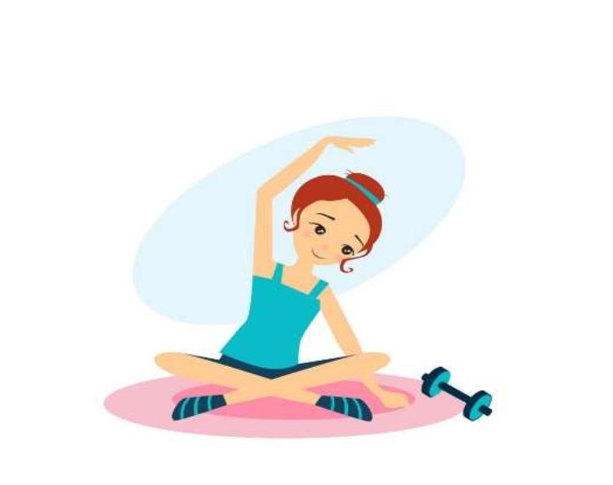

**2. PROCEDURE**

The second-year BCA Data Science students at Gayatri Vidya Parishad have embarked

on a social immersion project centered around Women's Health. Following a series of

preliminary trials involving various research methods, the final dataset has been collected.

This dataset provides insights into the health and habits of individuals across different age

groups residing in Visakhapatnam, Andhra Pradesh. The study exclusively involves women

from diverse occupational backgrounds, making it a comprehensive exploration of women's

health in this region

The students, trained and carefully supervised by a member of the immersion project,

interviewed approximately 180 women in various localities, different working sectors and age

groups between 25 to 60.

Each student talked alternately with women from different groups so that no constant

error due to the student’s personality or increasing routine would affect the results. A total of

180 people were interviewed, with approximately 30 by each person in the group. The survey

lasted from 5 to 15 minutes for each person.

5

**2.1 Questionnaire**

**Q.No**

**Question**

**Yes**

**No**

**1**

**2**

**3**

**4**

**5**

**Are you employed?**

**Are you having 3 meals per day?**

**Are you having your breakfast timely?**

**Are you having milk at least once in a day?**

**Are you having leafy vegetables thrice in a week?**

**Is protein includes in your diet?(Eg: peas, beans, egg, cereals &**

**nuts)**

**6**

**7**

**8**

**Is fiber content apart of your regularly?( Eg:oats,corn,wheat)**

**Are you having fruits regularly?**

**8.1 If yes, What fruits includes in your diet plan?**

**Apple Banana Guava Papaya pomegranate**

**Ans:--------------**

**----**

**any another----------------**

**9**

**Is exercise apart of your life style?**

**Ans: ----------**

**- Days**

**Ans:---------**

**mins/hrs**

**If yes, How many days in a week?**

**9.1**

**If yes, Duration of your exercise is --------min/hrs?**

**a) Min 30mins**

**b) 45mins**

**c) 1hr**

**Ans: ---------**

**- Liters**

**10 What is your water intake in a day?(Min 1.5l to Max 3.5L)**

**11 Are you sleeping 6 to 8 hours sleep regularly?**

**12 Are you suffering from Menopausal problems?**

**13 Do you have a family history of Diabetes?**

**14 Do you have family history of BP?**

**15 Do you have family history of Thyroid?**

6



**3. DATA COLLECTION**

A survey on women's health is currently being conducted by a dedicated team of six

individuals. This survey aims to gather valuable insights into the health and well-being of

women in Visakhapatnam, Andhra Pradesh across various age groups and professional

sectors. The data collected will contribute to a better understanding of women's health issues

in various regions and enable informed decisions for addressing them effectively.

Designing a survey on women's health is an important undertaking, as it can provide

valuable insights into various aspects of women's well-being. Below are steps and

considerations for creating a survey on women's health:

**1. Define Your Objectives:** Clearly define the objectives and goals of your survey. What

specific aspects of women's health are you interested in studying? Examples might include

reproductive health, access to healthcare, Food Habits, or specific health conditions.

**2. Target Audience:** Determine the target population for your survey. Are you focusing on

women of a certain age group, employment status, or socioeconomic status. Understanding

your target audience is crucial for designing relevant questions.

**3. Questionnaire Design:** Create a well-structured questionnaire with clear and concise

questions. Be mindful of the language used and avoid jargon. Consider the following topics:

• General health status

• Reproductive health (if applicable)

• Mental health and emotional well-being

• Access to healthcare services

• Health-related behaviours (e.g., exercise, diet, sleep)

• Specific health conditions or diseases of interest

**4. Ethical Considerations:** Ensure that your survey adheres to ethical guidelines, including

obtaining informed consent from participants. Assure respondents of the confidentiality and

anonymity of their responses.

7

**5. Data Collection:** Determine the data collection method, whether it's phone interviews,

face-to-face interviews, or a combination of methods. Ensure that the method is accessible

and convenient for your target audience.

**7. Pilot Test:** Before launching the full survey, conduct a pilot test with a small group of

women to identify and address any issues with the questionnaire and data collection process.

**8. Data Analysis:** Plan how you will analyze the survey data. Depending on the complexity

of your questions, this might involve descriptive statistics, regression analysis, or other

statistical methods.

**9. Reporting:** Summarize your findings in a clear and concise report. Consider publishing

your results in your records or sharing them with relevant organizations.

**10. Continuous Improvement:** - Use the feedback from your survey to improve future

surveys or research efforts related to women's health.

8

**3.1 Sample Data**

9

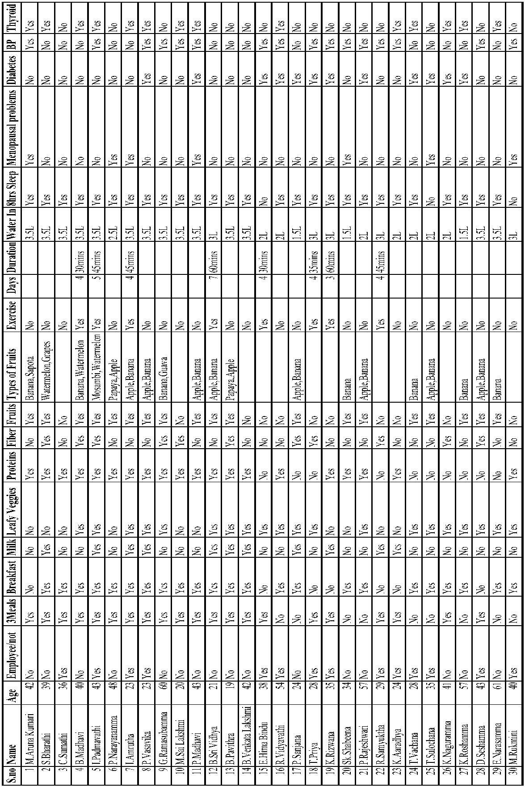

10

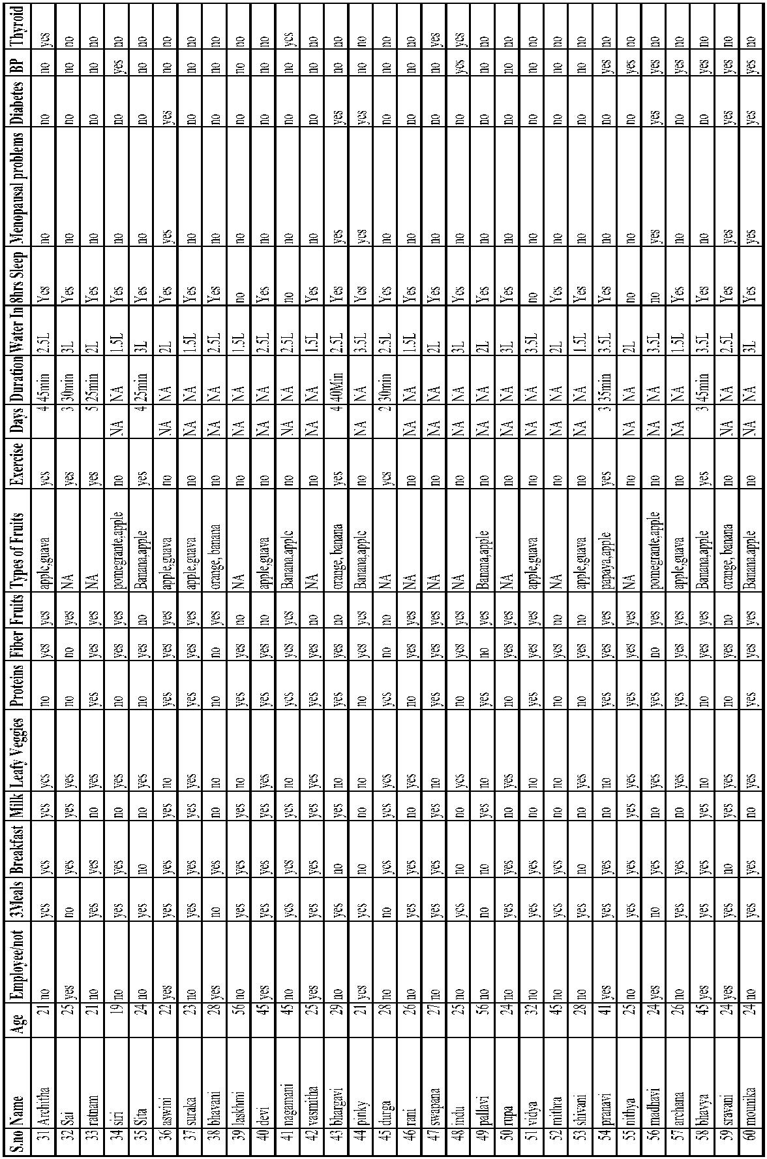

11

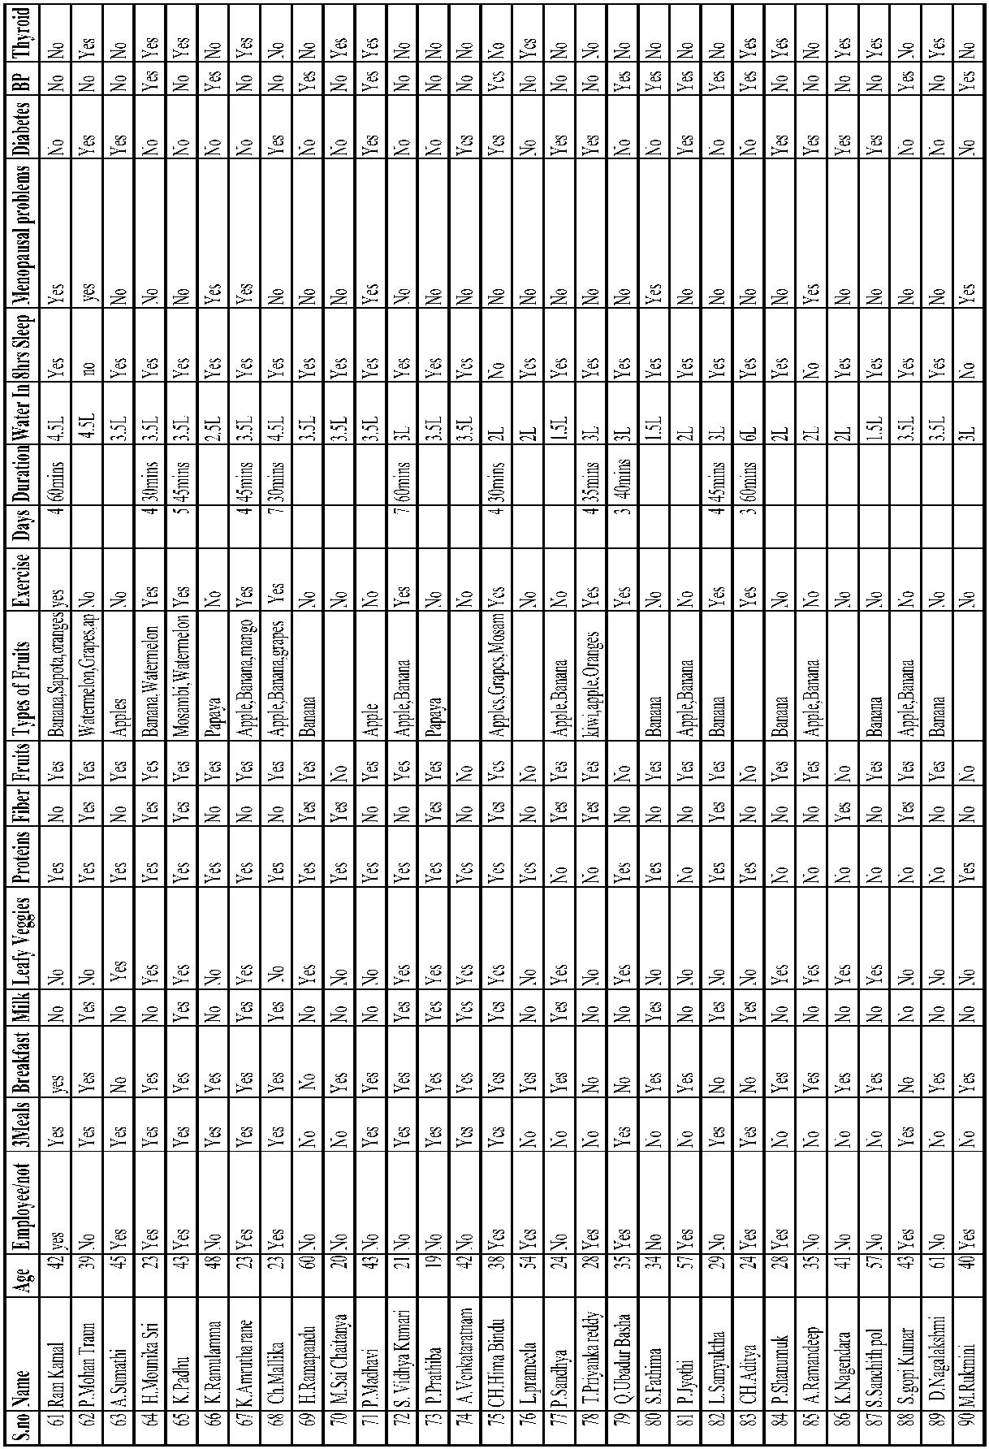

12

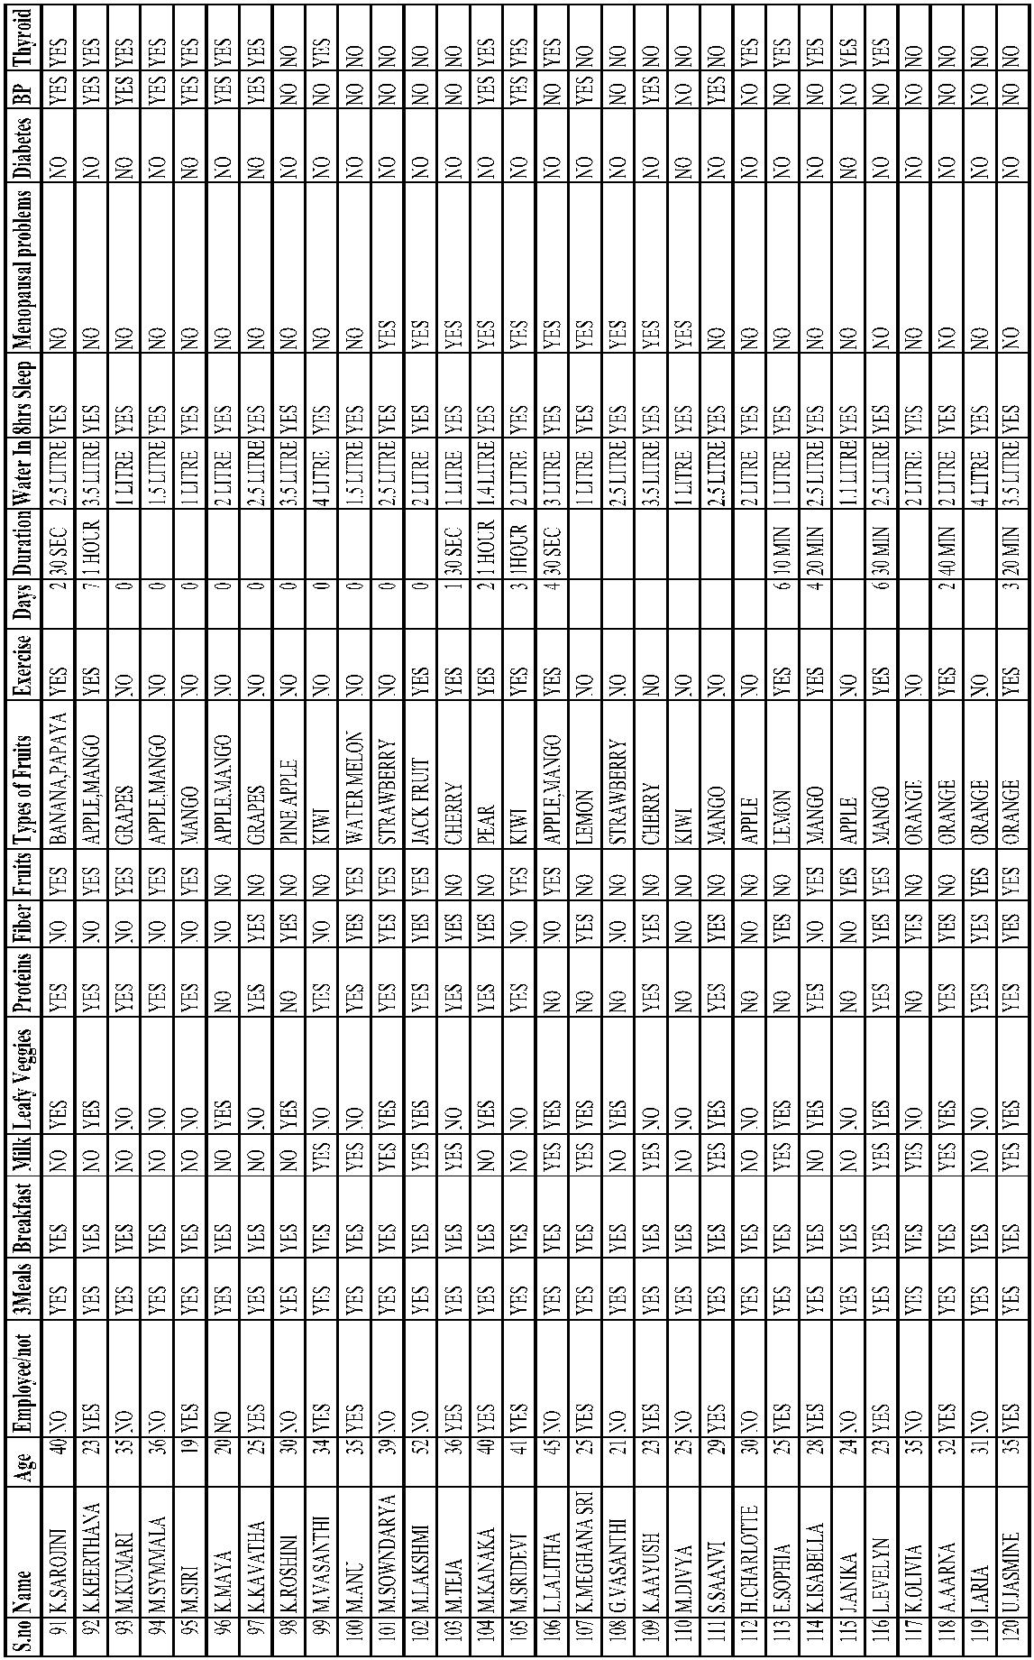

13

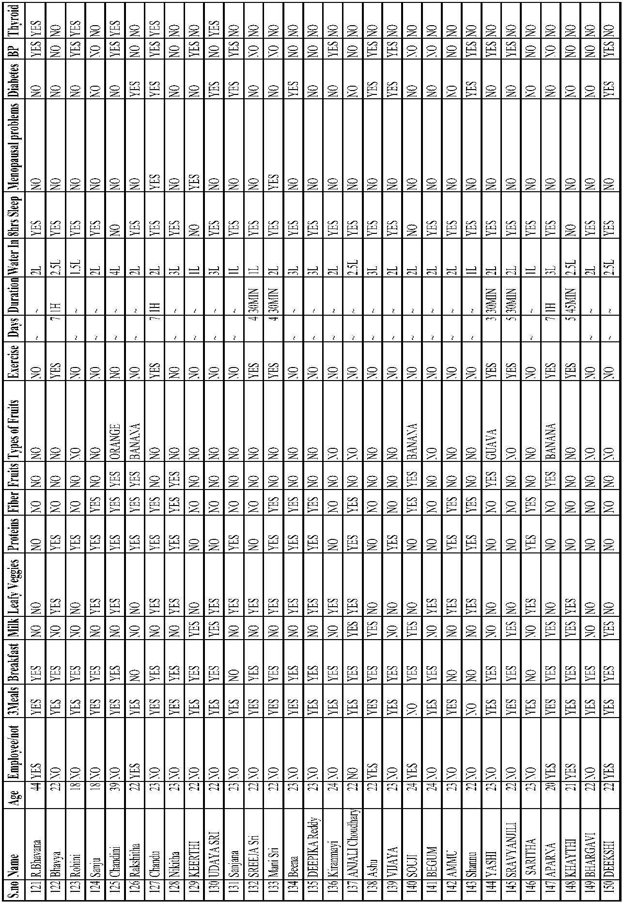

14

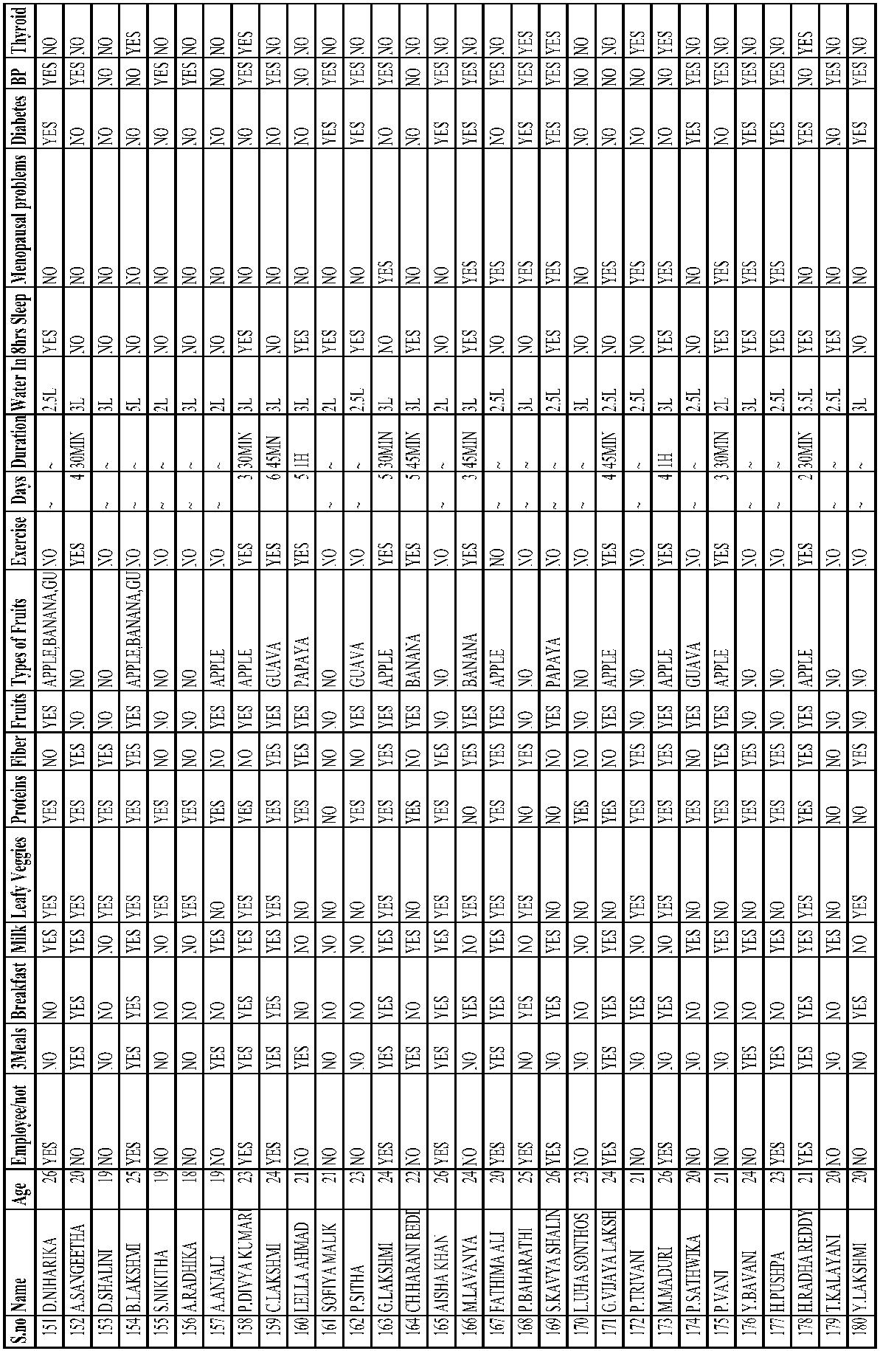

**4. OBJECTIVE OF THE STUDY**

The Community Science Project has specific objectives,

• To sensitize the students to the living conditions of the people who are around them.

• To help students to realize the stark realities of the society.

• To bring about an attitudinal change in the students and help them to develop societal

consciousness, sensibility, responsibility and accountability.

• To make students aware of their inner strength and help them to find new/out-of-the-

box solutions to social problems.

• To make students socially responsible citizens who are sensitive to the needs of the

disadvantaged sections.

• To help students to initiate developmental activities in the community in coordination

with public and government authorities.

• To develop a holistic life perspective among the students by making them study

culture, traditions, habits, lifestyles, resource utilization, wastages and its

management, social problems, public administration system and the roles and

responsibilities of different persons across different social systems.

15

**5. EXPECTED OUTCOMES**

**5.1 Benefits of Community Service Project to Students**

A group of students was assigned to Visakhapatnam District. Firstly, this group of

students conducted a survey interacted with the people and conducted awareness rallies in

the area.

Secondly, the students take up a project work related to Women's Health.

**5.2 Learning Outcomes**

• Positive impact on student's academic learning.

• Improves students' ability to apply what they have learned in the real world " Positive

impact on academic outcomes such as demonstrated complexity of understanding,

problem analysis, problem-solving, critical thinking, and cognitive development.

• Improved ability to understand complexity and ambiguity.

**5.3 Personal Outcomes**

• Greater sense of personal efficacy, personal identity, spiritual growth, and moral

development.

• Greater interpersonal development, particularly the ability to work well with others,

and build leadership and communication skills.

**5.4 Social Outcomes**

• Reduced stereotypes and greater intercultural understanding.

• Improved social responsibility and citizenship skills.

• Greater involvement in community service after graduation.

16

**5.5 Career Development**

• Connections with professionals and community members for learning and career

opportunities.

• Greater academic learning, leadership skills, and personal efficacy can lead to greater

opportunity.

**5.6 Relationship with the Institution**

• Stronger relationships with faculty.

• Greater satisfaction with college.

• Improved graduation rates.

**5.7 Benefits of Community Service Project to Faculty Members**

• Satisfaction with the quality of student learning.

• New avenues for research and publication via new relationships between faculty and

community.

• Providing networking opportunities with engaged faculty in other disciplines or

institutions.

• A stronger commitment to one's research.

17

**6. ANALYSIS OF THE DATA**

A team of 6 students signed a project in Visakhapatnam District. Firstly, this group of

students conducted a survey to interact with the women of their local residents and conducted

awareness rallies.

Secondly, the students take up a project work related to Women's Health.

In this survey, we interacted with the women and learned about their daily routine of

their food habits and exercise and found how the people of the village are aware of balanced

diet and physical fitness. We collected data from the women regarding the major issues related

to the health, social, cultural, and economic well-being of women.

•

•

•

•

•

•

•

•

•

•

•

•

•

•

•

•

•

Number of women surveyed -180

Number of women employed - 105

Number of women taking 3 meals per day - 135

Number of women having breakfast timely - 139

Number of women of age between 25 to 30 Years - 31

Number of women of age between 31 to 40 Years - 28

Number of women of age between 41 to 50 Years - 23

Number of women of age between 51 to 60 Years - 11

Number of people of age more than 59 Years - 04

Percentage of women daily balanced diet daily - 61%

Number of women who eat fruits regularly - 101

Number of women are exercising daily - 7

Number of women having 6 to 8 hours of sleep - 148

Number of women suffering from Menopausal problems - 44

Number of women having a family history of Diabetes - 52

Number of women having a family history of BP - 82

Number of women having a family history of Thyroid - 58

18

**6.1 Women Employability-Wise Collected Data**

We are collected the data of 180 women from the village by asking them do they

employed or not the following bar graph and pie chart shows number of women employed.

**WOMEN EMPLOYMENT**

105

75

Y E S

N O

E M P LO Y E M E N T

***Fig-6.1: Bar chart showing women employment***

**Women Employment**

**41.67%**

EMPLOYEMENT YES

EMPLOYEMENT NO

**58. 58%**

***Fig-6.2: Pie chart showing Women Employment***

19

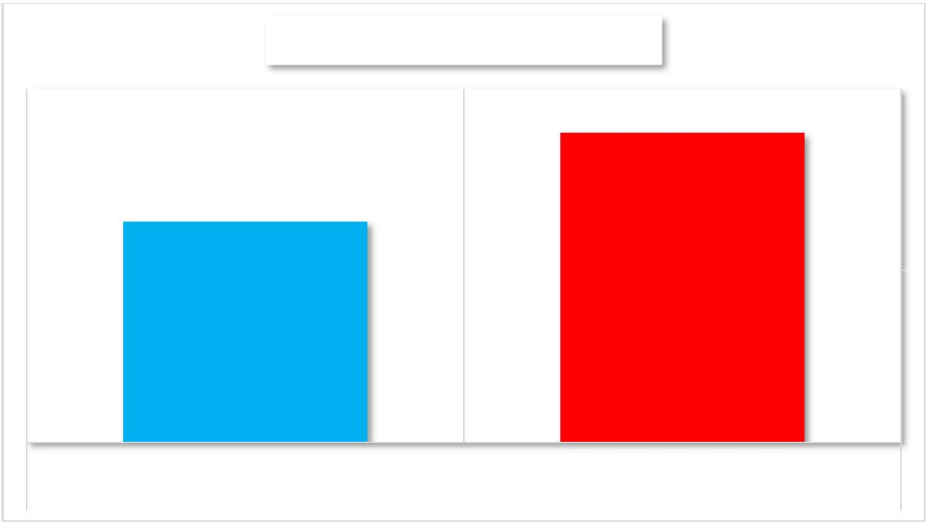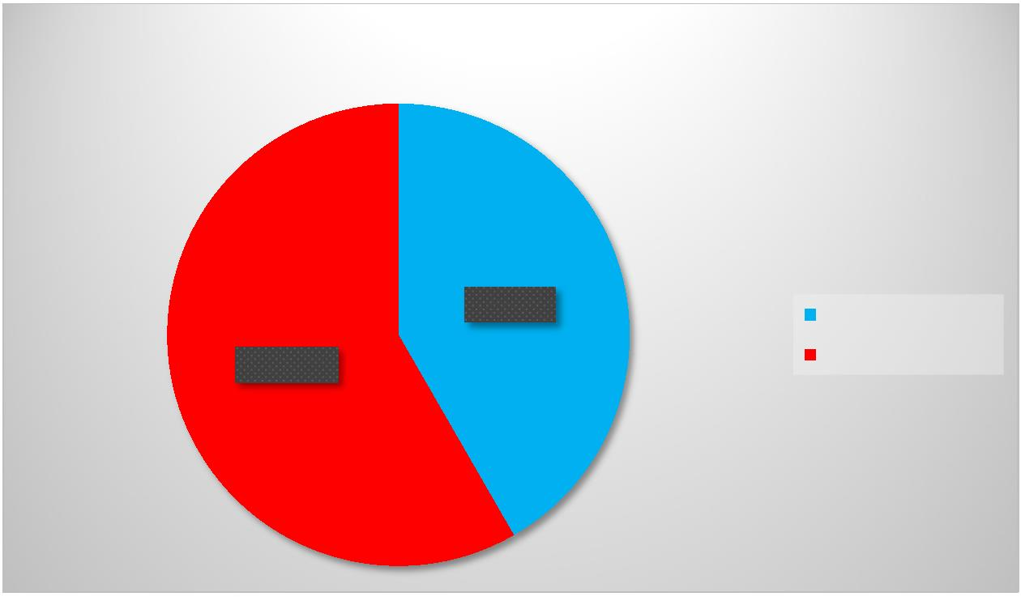

**6.2 Health Issues-Wise Collected Data**

We collected the data of 180 women from the village by asking them about their health

issues. The following bar graph and pie chart show the number of women who suffered from

various health issues.

**HEALTH ISSUES**

140

120

100

80

135

128

122

98

82

58

52

60

44

40

20

0

MENOPAUSAL

PROBLEMS

DIABETES

BP

THYROID

YES NO

***Fig-6.3: Bar chart showing Health Issues***

**HEALTH ISSUES**

**44**

**58**

Menopausal problems

Diabetes

BP

**52**

Thyroid

**82**

***Fig-6.4: Pie chart showing Health Issues***

20

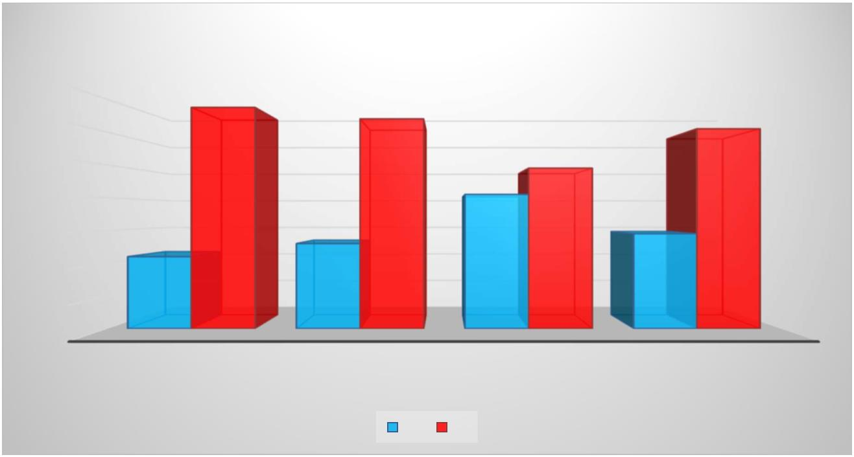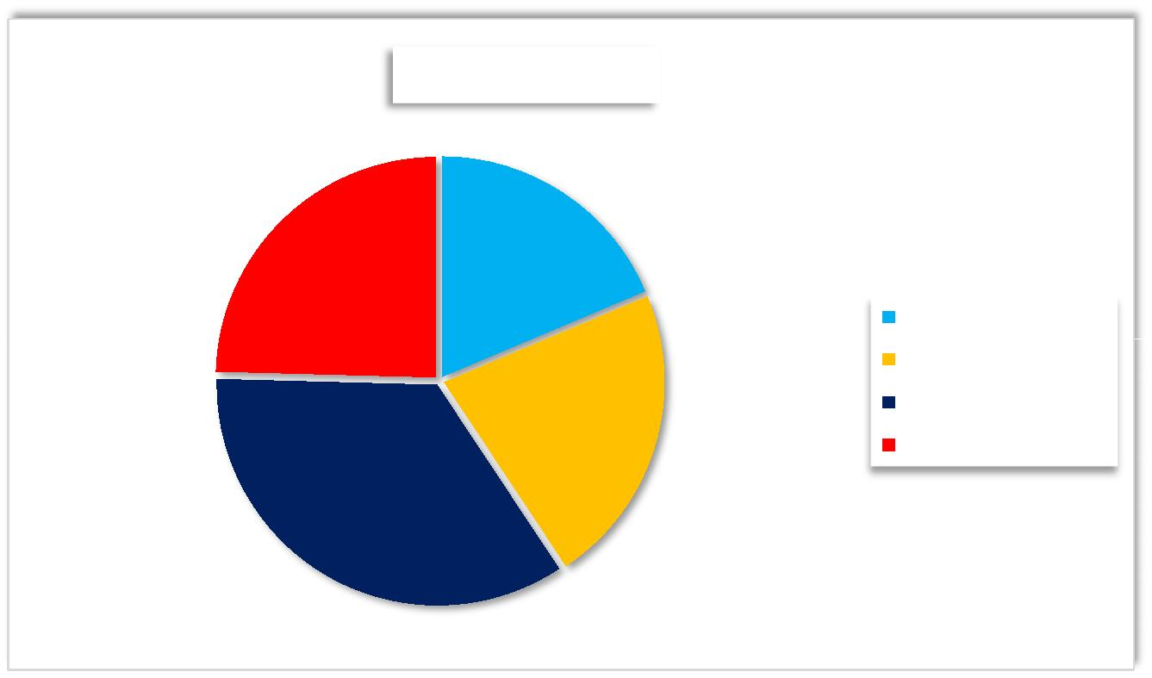

**6.3 Physical Wellness-Wise Collected Data**

We collected the data of 180 women from the village by asking them about their

physical wellness the following graph shows number of women about their physical fitness.

**PHYSICAL FITNESS**

140

120

100

80

60

40

20

0

123

YES

NO

57

YES

NO

***Fig-6.5: Bar chart showing Physical Fitness***

**PHYSICAL FITNESS**

**57%**

YES

NO

**68.3%**

***Fig-6.6: Pie chart showing Physical Fitness***

21

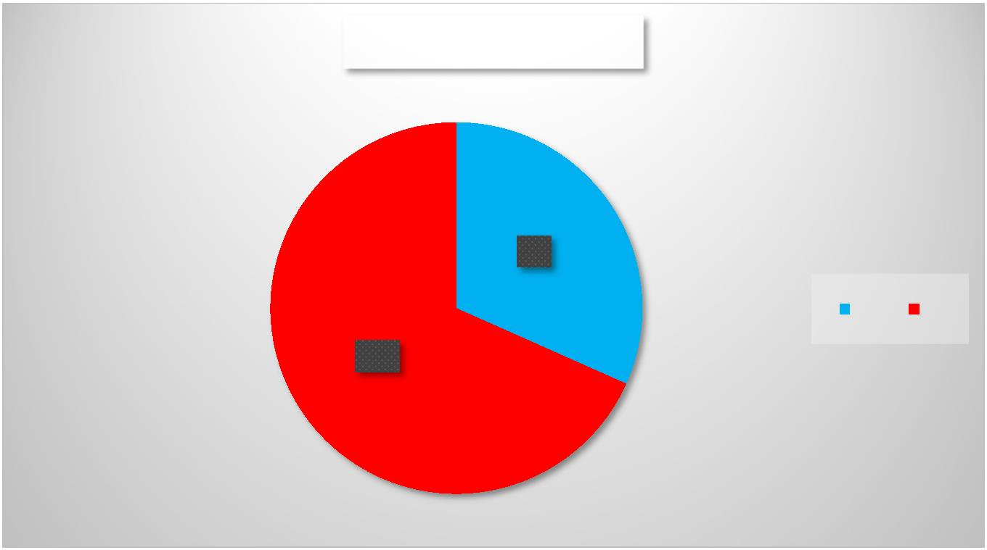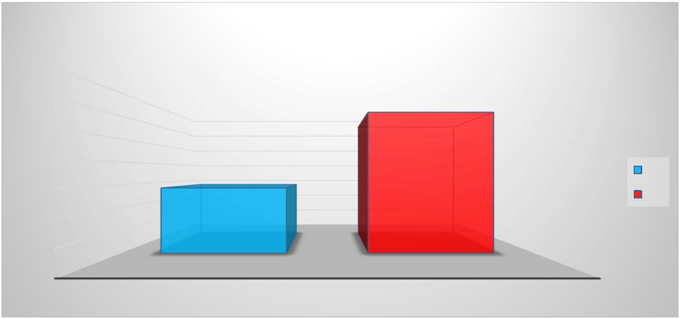

**7. SUMMARY**

Based on the data collected from the survey of 180 women in their residence, several

important findings about their employment, dietary habits, exercise routines, and health

problems can be drawn.

**1. Employment Status:** Out of the 180 women surveyed, 75 women reported being

employed, indicating that employment is relatively common among the respondents.

**2. Dietary Habits:** A significant portion of the women surveyed are following healthy

dietary habits:

•

•

•

•

•

118 women (65.6%) consume proteins in their food.

94 women (52.2%) include fibre in their diet.

101 women (56.1%) consume fruits regularly.

103 women (57.2%) incorporate leafy vegetables into their meals.

On average, approximately 61% of the women surveyed appear to be

maintaining a balanced diet.

**3. Exercise Habits:** Exercise habits among the respondents are relatively low:

•

•

•

Only 7 women (3.9%) reported daily exercise.

12 women (6.7%) exercise three days a week.

18 women (10%) engage in exercise five days or more per week.

**4. Health Problems:** A significant portion of the surveyed women reported facing

various health issues:

•

•

•

•

27.5% are experiencing menopausal problems.

28.8% have diabetes.

46% are dealing with high blood pressure.

32.2% are affected by thyroid problems.

22

**5. Meal Patterns:** It was found that 135 women (75%) have three meals per day, while

139 women (77.2%) have breakfast regularly.

The data reveals that while a substantial number of women have healthy dietary habits,

exercise routines need improvement among the surveyed group. Additionally, a significant

proportion of women face health challenges, including diabetes, high blood pressure, and

thyroid issues. These findings suggest the importance of promoting regular exercise and

health awareness in the community, particularly in managing prevalent health issues.

23

**8. CONCLUSION**

The findings of our survey among 180 women in our communities underscore both positive trends and areas for improvement in women's health and well-being. While a considerable number of women are gainfully employed and exhibit commendable dietary habits, there are notable opportunities for enhancement in various aspects of their health. To foster a healthier community, we recommend several measures. First and foremost, there is a pressing need to promote regular exercise. Establishing accessible community exercise programs and conveying the benefits of physical activity in managing health conditions can be pivotal. Furthermore, elevating health awareness is paramount. Initiating community-wide health campaigns, offering screenings, and encouraging regular health check-ups can empower women to take charge of their well-being. Simultaneously, we must emphasize the importance of balanced nutrition, encouraging the consumption of fruits, vegetables, and fiber-rich foods. Building a stronger sense of community and support, improving access to health care, and advocating for work-life balance among employed women are all steps towards holistic well-being. In conclusion, by implementing these measures and nurturing a culture of health, we can work collaboratively to enhance the health and quality of life for women in our community, addressing prevailing health concerns and fostering a brighter and healthier future. Building a stronger sense of community and support, improving access to healthcare, and advocating for work-life balance among employed women are all steps towards holistic well-being.

24